- Configure VPC peering in cross regions.
- First we need to create to separate vpc,subnet,route,INT-GW …we are creating two separate vpc from different region and also some region as vpc instances but make changes in networking select ur region wise vpc and subnet
- Make sure you enable host name from vpc > action > edit vpc setting > dns setting > enable dns hostname.
Request side peering
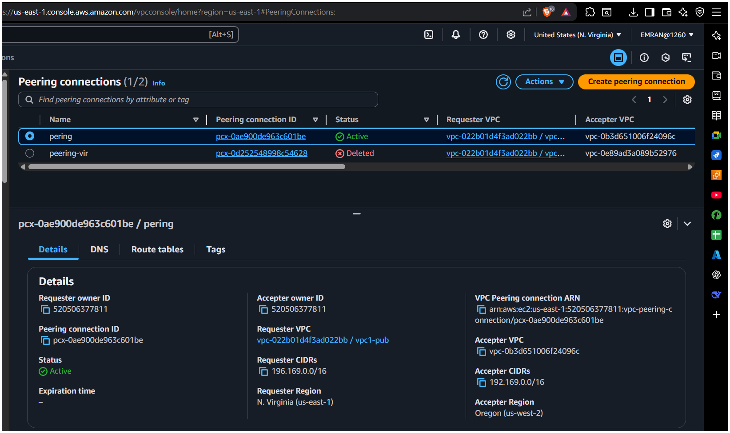
Accepter side peering
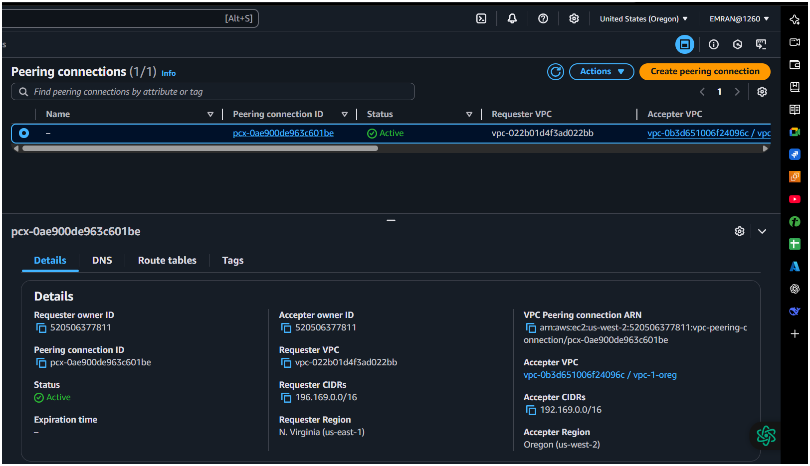
Checking connection
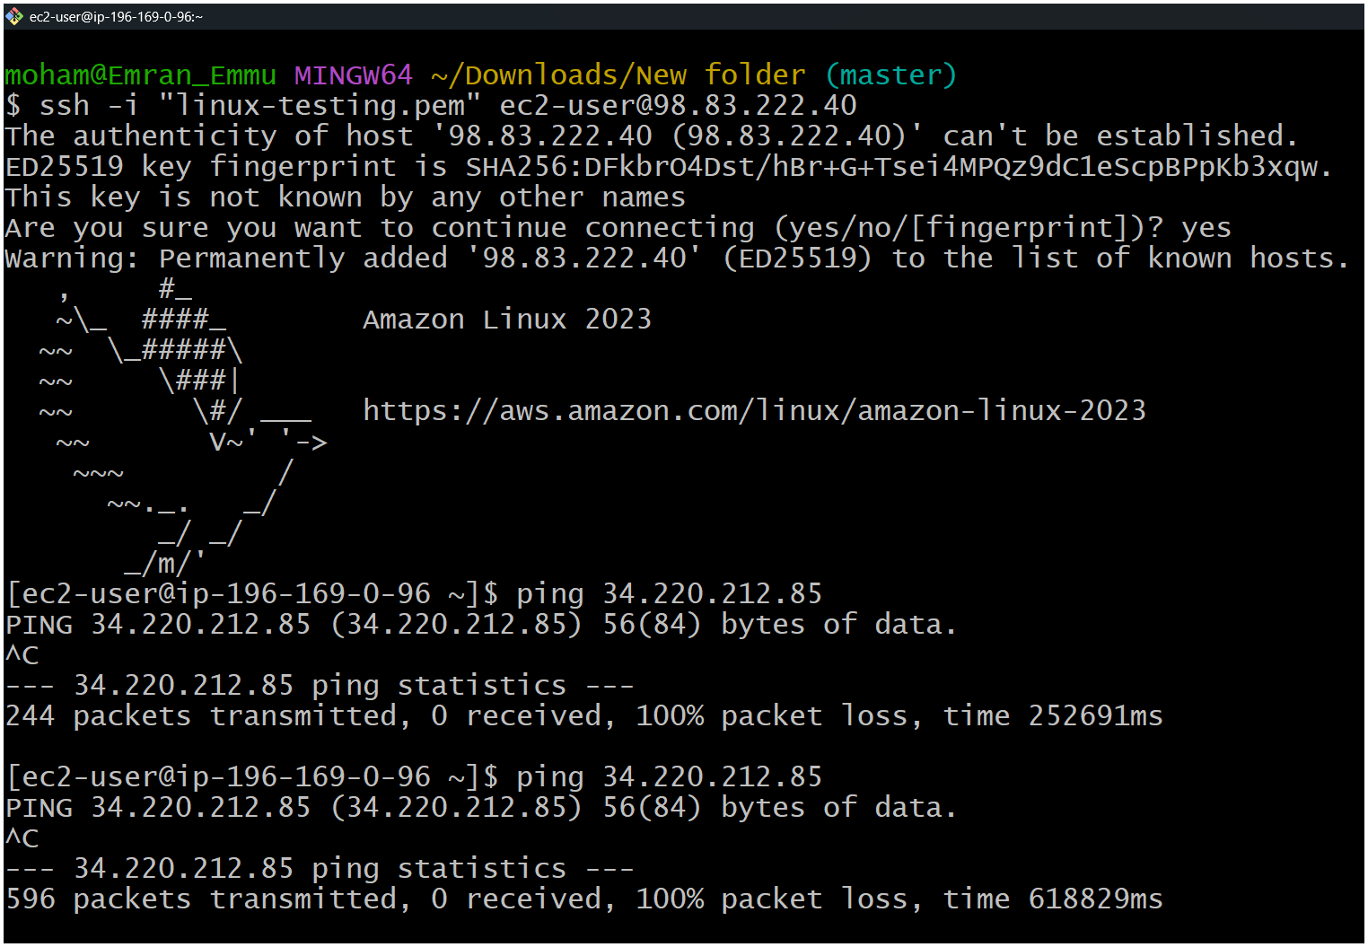
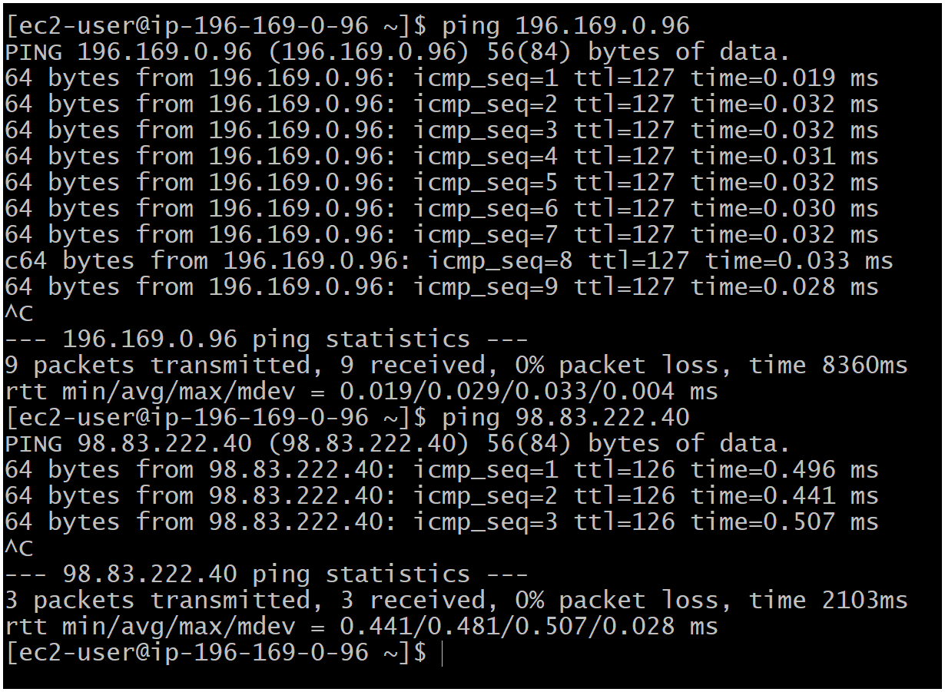
- Purchase one domain from godaddy.
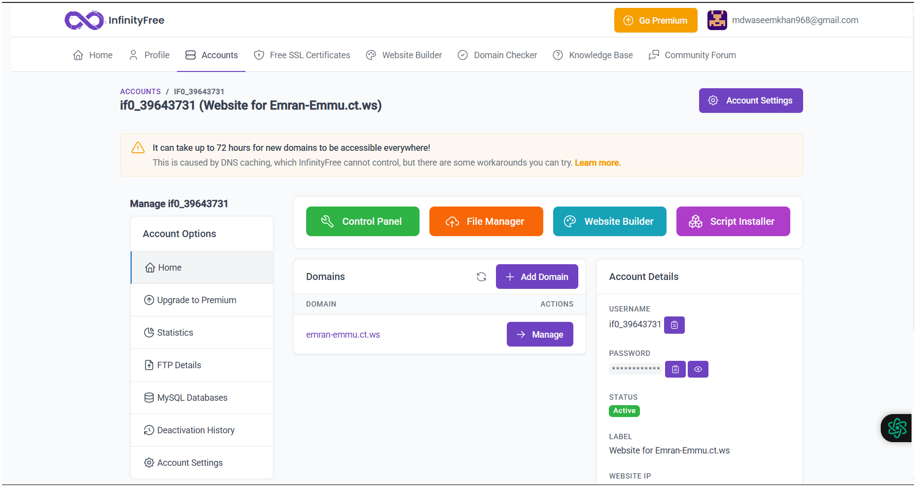
Emran-Emmu.ct.ws
- Deploy static webiste in s3.
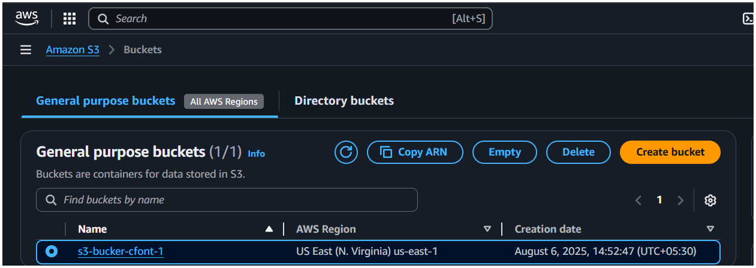
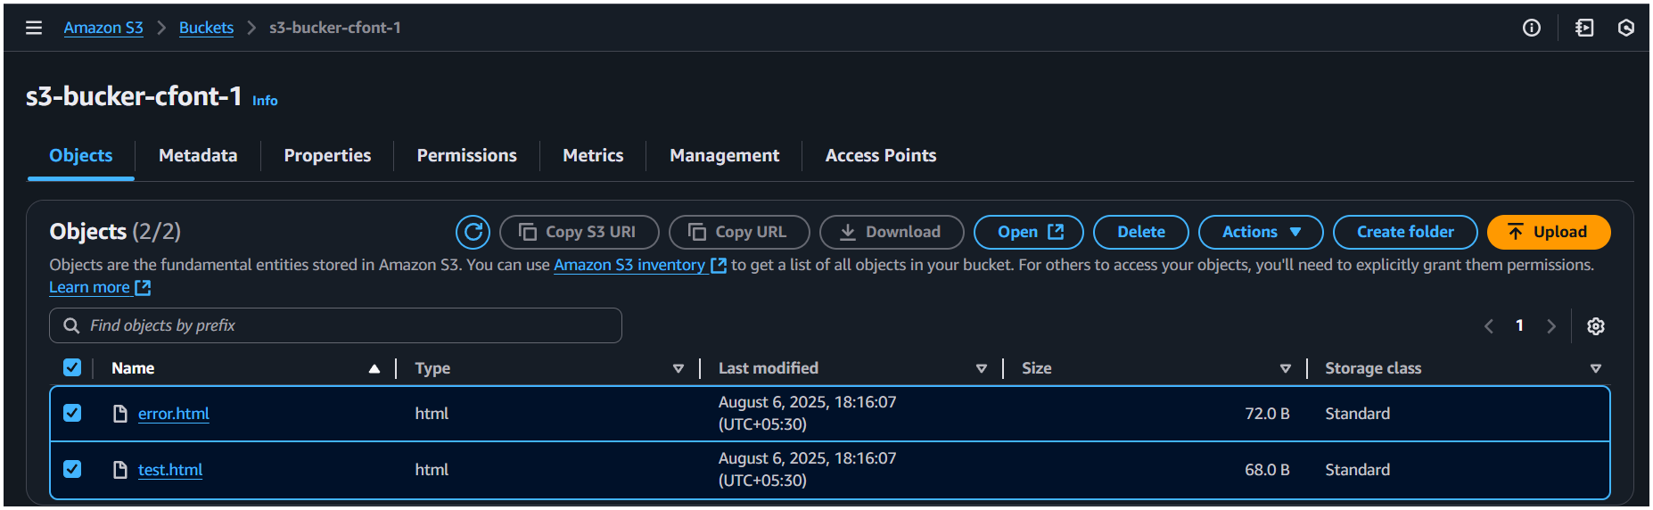
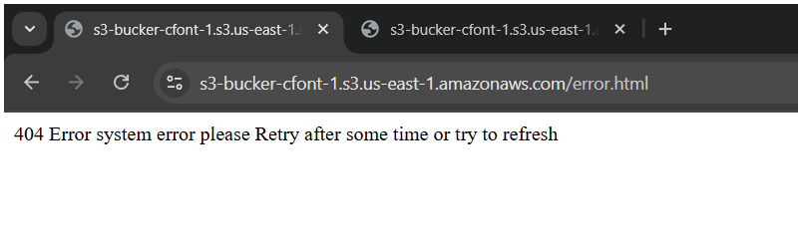
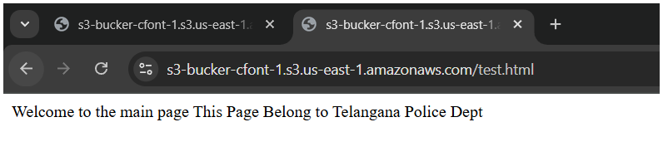
4) Create CDN and attach one SSL certificate.

5) Create Route53 hosted zone and MAP the domain with CDN.

6) Update the index.html in s3 bucket and the updated file should be accessible by using domain name.

7) Share the Domain name in slack to test the connetivity.

